Lab 7 - Central Limit Theorem

1. Central Limit Theorem
The Central Limit Theorem (CLT) states that the sampling distribution of the sample mean approaches a normal distribution as the sample size becomes large, regardless of the population's distribution.
For a population with mean μ and standard deviation σ, the distribution of the sample mean $\overline{X}$ for large sample sizes n is approximately normal with:
- Mean = μ
- Standard deviation (standard error) = 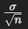​
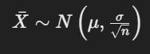
Thus, the CLT is a powerful tool that justifies the use of normal approximations for sample statistics in many real-world situations.

Key Points of the Central Limit Theorem:
- Normality of Sample Means:
  - The CLT states that as the sample size increases, the distribution of the sample means approaches a normal (Gaussian) distribution.
  - This holds true even if the population distribution is not normal (e.g., skewed, uniform, or binomial).
- Mean of the Sample Means:
  - The mean of the distribution of the sample means will be equal to the population mean (denoted as μ).
  - If the population mean is μ, the mean of the sample means will also be μ.
- Standard Error (SE):
  - The standard deviation of the sample means (called the standard error) decreases as the sample size increases. It is calculated as:
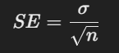
where σ is the population standard deviation and nnn is the sample size.
  - This shows that the larger the sample size, the smaller the spread of the sample means, making the distribution more concentrated around the population mean.
- Convergence to Normality:
  - For a large enough sample size (usually n≥30 is considered sufficient), the distribution of the sample means becomes approximately normal, even if the underlying population distribution is not.
- Application:
  - The CLT allows statisticians to make inferences about the population mean using the sample mean.
  - It is widely used in hypothesis testing, confidence intervals, and probability calculations because the normal distribution is well understood and easy to work with.
In all these below cases, you can see the CLT at work, with the sample means forming a bell-shaped (normal) curve.

2. Sampling from a Uniform Distribution
In this example, we will generate random samples from a uniform distribution and show how the distribution of the sample means approaches a normal distribution.
import numpy as np
import matplotlib.pyplot as plt

# Set parameters
n = 30 # Sample size
num_samples = 1000 # Number of samples

# Generate samples from a uniform distribution
uniform_samples = np.random.uniform(low=0, high=1, size=(num_samples, n))

# Compute the means of each sample
sample_means = np.mean(uniform_samples, axis=1)

# Plot the histogram of sample means
plt.figure(figsize=(10, 6))
plt.hist(sample_means, bins=30, density=True, alpha=0.6, color='g')

# Plot the normal distribution
mean = np.mean(sample_means)
std = np.std(sample_means)
x = np.linspace(mean - 4*std, mean + 4*std, 1000)
plt.plot(x, (1/(std * np.sqrt(2 * np.pi))) * np.exp(- (x - mean)**2 / (2 * std**2)), color='r')

plt.title("Central Limit Theorem - Uniform Distribution")
plt.xlabel("Sample mean")
plt.ylabel("Frequency")
plt.show()

The uniform distribution is originally flat, but the distribution of the sample means tends to be normal.
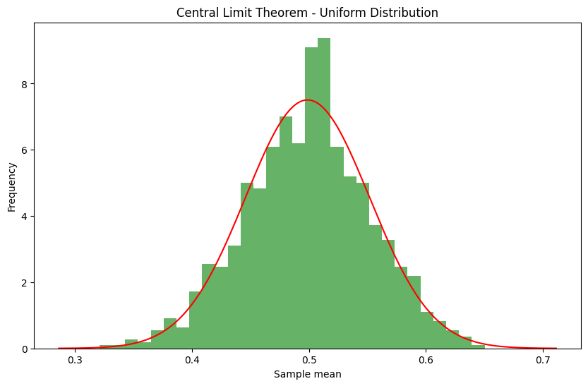

3. Sampling from an Exponential Distribution
Now, let’s sample from an exponential distribution, which is highly skewed. The sample means will still converge to a normal distribution as we take more samples.
# Set parameters
n = 30 # Sample size
num_samples = 1000 # Number of samples

# Generate samples from an exponential distribution
exponential_samples = np.random.exponential(scale=1, size=(num_samples, n))

# Compute the means of each sample
sample_means = np.mean(exponential_samples, axis=1)

# Plot the histogram of sample means
plt.figure(figsize=(10, 6))
plt.hist(sample_means, bins=30, density=True, alpha=0.6, color='g')

# Plot the normal distribution
mean = np.mean(sample_means)
std = np.std(sample_means)
x = np.linspace(mean - 4*std, mean + 4*std, 1000)
plt.plot(x, (1/(std * np.sqrt(2 * np.pi))) * np.exp(- (x - mean)**2 / (2 * std**2)), color='r')

plt.title("Central Limit Theorem - Exponential Distribution")
plt.xlabel("Sample mean")
plt.ylabel("Frequency")
plt.show()

The exponential distribution is skewed, but the sample means also approach normality.
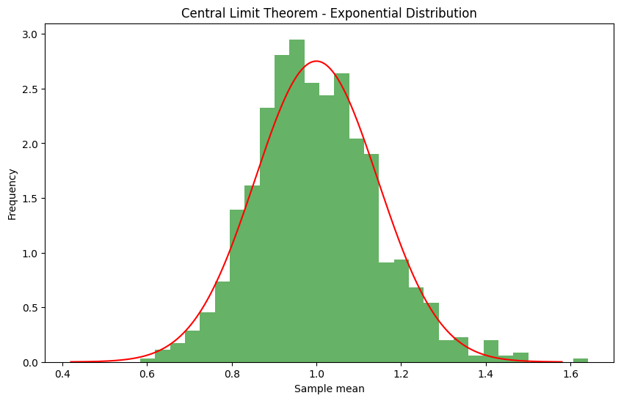

4. Sampling from a Binomial Distribution
In this case, we’ll generate random samples from a binomial distribution and observe how the sample means approach normality.
# Set parameters
n = 30 # Sample size
num_samples = 1000 # Number of samples

# Generate samples from a binomial distribution
binomial_samples = np.random.binomial(n=10, p=0.5, size=(num_samples, n))

# Compute the means of each sample
sample_means = np.mean(binomial_samples, axis=1)

# Plot the histogram of sample means
plt.figure(figsize=(10, 6))
plt.hist(sample_means, bins=30, density=True, alpha=0.6, color='g')

# Plot the normal distribution
mean = np.mean(sample_means)
std = np.std(sample_means)
x = np.linspace(mean - 4*std, mean + 4*std, 1000)
plt.plot(x, (1/(std * np.sqrt(2 * np.pi))) * np.exp(- (x - mean)**2 / (2 * std**2)), color='r')

plt.title("Central Limit Theorem - Binomial Distribution")
plt.xlabel("Sample mean")
plt.ylabel("Frequency")
plt.show()

The binomial distribution shows how even for a discrete distribution, the CLT holds as we take more samples.
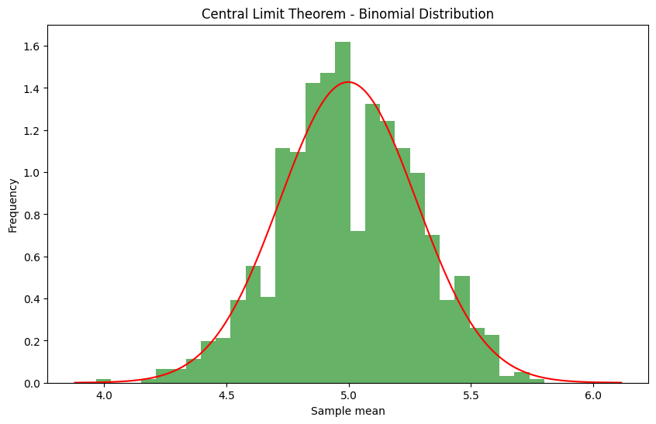

5. Exercises

Exercise 1: Understanding the CLT
Consider a population that follows a highly skewed distribution, such as an exponential distribution with a mean of 5. You take random samples of size 30 from this population. According to the Central Limit Theorem:
a) What would be the shape of the distribution of the sample means?
b) What happens to the distribution of sample means as the sample size increases?

Exercise 2: Sample Mean Distribution
Suppose the heights of a population of people follow a skewed distribution with a mean of 170 cm and a standard deviation of 15 cm. You take random samples of 40 people at a time.
a) What is the expected mean of the distribution of sample means?
b) What is the standard deviation of the distribution of sample means (standard error)?

Exercise 3: Probability Using the CLT
Assume the weights of a certain population are normally distributed with a mean of 70 kg and a standard deviation of 10 kg. A random sample of size 50 is taken. What is the probability that the sample mean weight is between 68 kg and 72 kg?

Exercise 4: Approximating a Binomial Distribution Using the CLT
A factory produces light bulbs, and the probability that a bulb is defective is 0.05. If a random sample of 200 bulbs is taken, use the Central Limit Theorem to approximate the probability that more than 12 bulbs in the sample will be defective.

Exercise 5: Effect of Sample Size
You have a population with a mean of 100 and a standard deviation of 20. Suppose you take samples of size 25 and calculate the sample mean.
a) What is the expected mean and standard error of the sample means?
b) Now suppose you increase the sample size to 100. How does this affect the standard error of the sample means?

